**Chapter – 4**

**RESULTS ANALYSIS AND VALIDATION**

**4.1** **Modern Tools Used In Design and Analysis:**

The name ‘CUCHD Faculties’ suggests that this is any college or university website. So we use many programming languages like HTML, CSS, JS, PHP, My SQL, and many more. To handle these languages we use entire initial tools that we need for making any website.

**Software tools:**

* **VS Code**:

Visual Studio Code is a streamlined code editor with support for development operations like debugging, task running, and version control. It aims to provide just the tools a developer needs for a quick code-build-debug cycle and leaves more complex workflows to fuller featured IDEs, such as Visual Studio IDE.

* **My SQL**:

MySQL is an open-source relational database management system. Its name is combination of “My”, the name of co-founder Michael Widenius's daughter, and "SQL", the abbreviation for Structured Query Language. In CUCHD Faculties this use for making the database of the whole website

* **XAMPP Server**:

XAMPP helps a local host or server to test its website and clients via computers and laptops before releasing it to the main server. It is a platform that furnishes a suitable environment to test and verify the working of projects based on Apache, Perl, MySQL database, and PHP through the system of the host itself.

* **Tawk.to**:

Tawk.to is a site that provides chat bot to CUCHD Faculties web. This provides live chat as well as inbuilt chats to the users. Which helps the clients if they face any problem in operating the website?

* **Pinterest**:

Pinterest is a social site where you can collect and share images of anything you find interesting. You can also visually discover new interests by browsing the collections of other [Pinterest users](https://www.lifewire.com/most-popular-pinterest-users-to-follow-3485976). We use this site for collecting all the images for the website.

* **Sublime text**:

Sublime Text is a shareware cross-platform source code editor. It natively supports many programming languages and markup languages. Users can expand its functionality with plug-in, typically community-built and maintained under free-software licenses. To facilitate plug-ins, Sublime Text features a Python API. The whole CUCHD Faculties website phages are done in the sublime text editor. This is an advanced editor which mainly helps in making HTML, CSS, JS, PHP files.

**4.2 SYSTEM SPECIFICATION:**

The hardware and software requirements for the development phase of our projects are:

**Software requirements:**

* Windows 10/ 11
* VS Code.
* Mysql
* XAAMP Server

**Hardware requirements:**

* Dual-core 64-bit processor.
* Upto 4GB of memory.
* Upto 4GB of internal storage Android SDK:2GB
* Windows SDK: 4GB.
* Network interface card

**4.3 Project Screen Shots:**

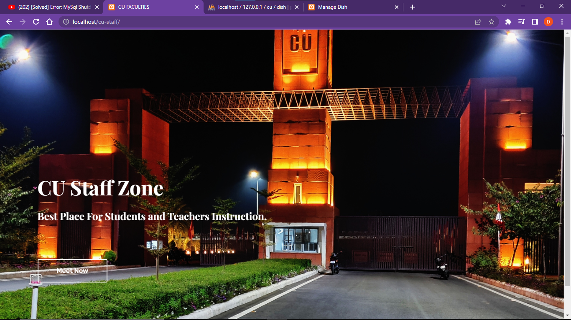

Figure 4.3.1[Front Page]

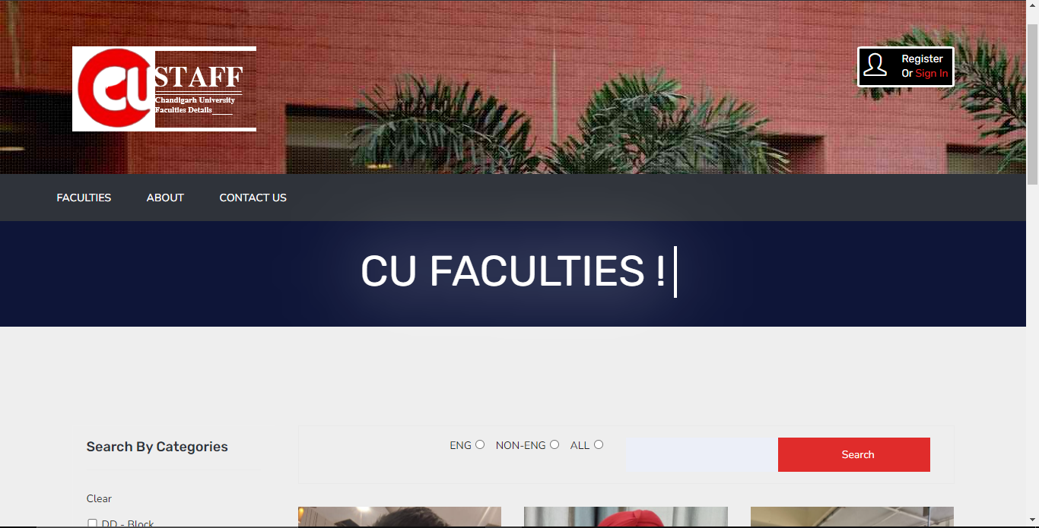

Figure 4.3.2[Home Page-1]

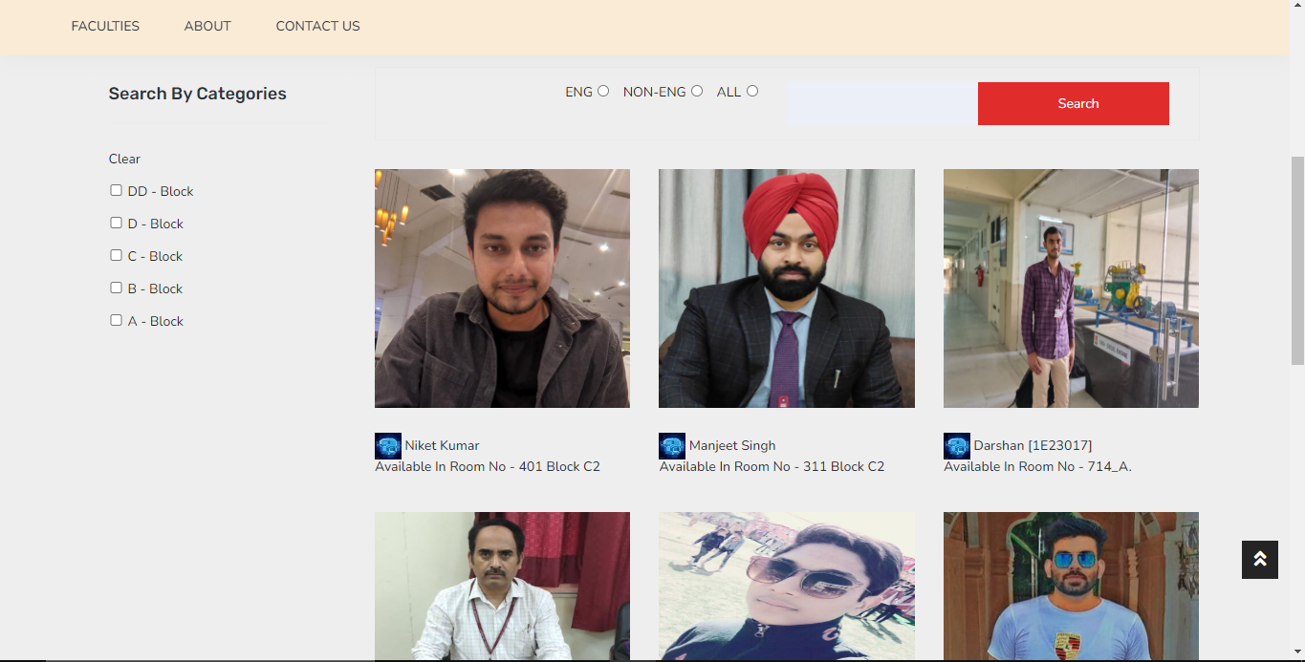

Figure 4.3.3[Home Page-2]

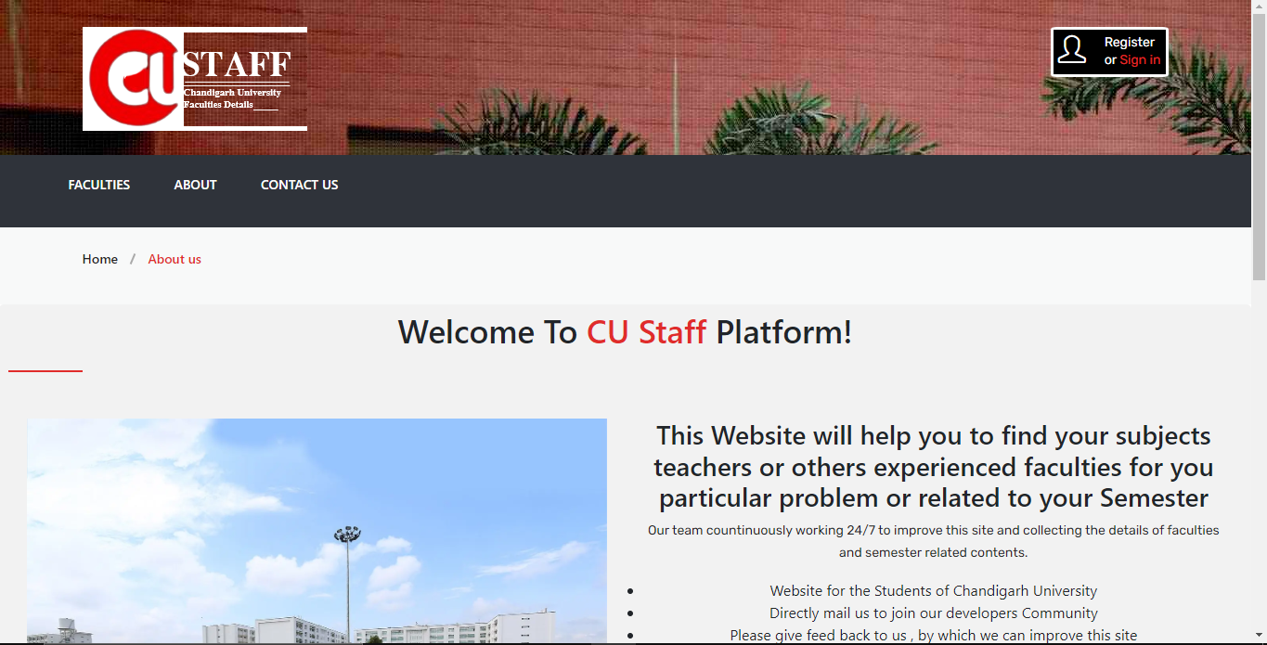

Figure 4.3.4[About Page]

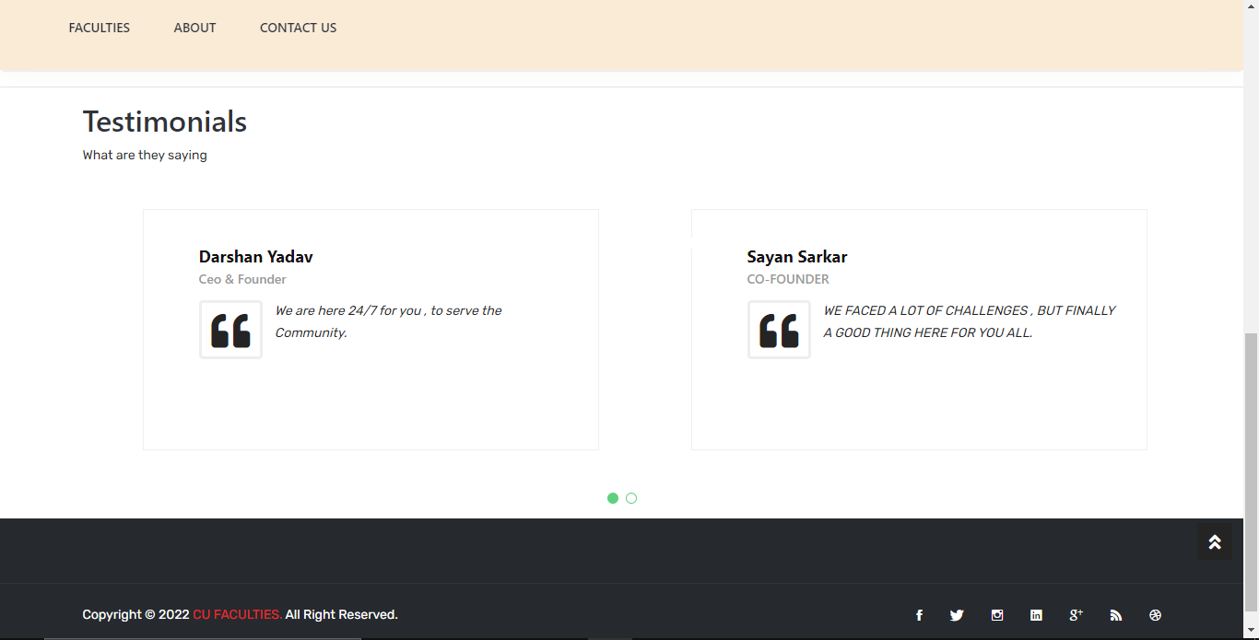

Figure 4.3.5[Testimonials Page]

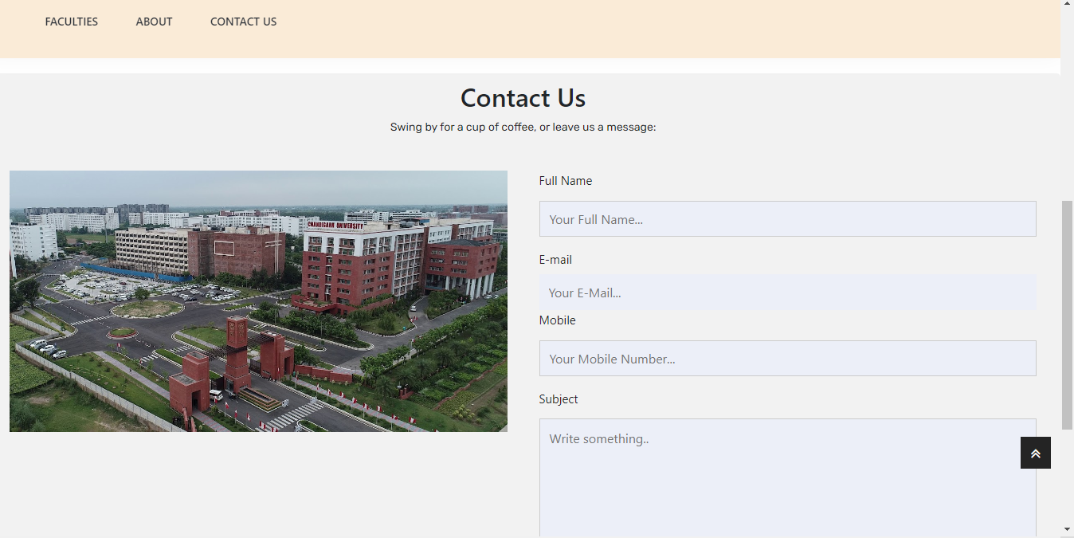

Figure 4.3.6[Contact Page]

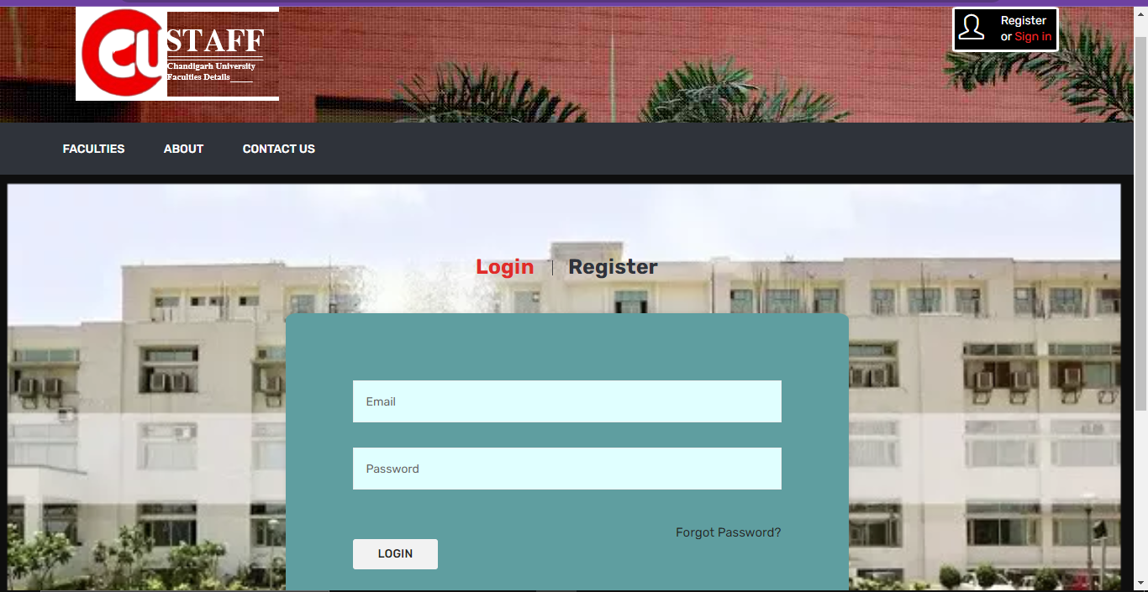

Figure 4.3.7[Login Page]

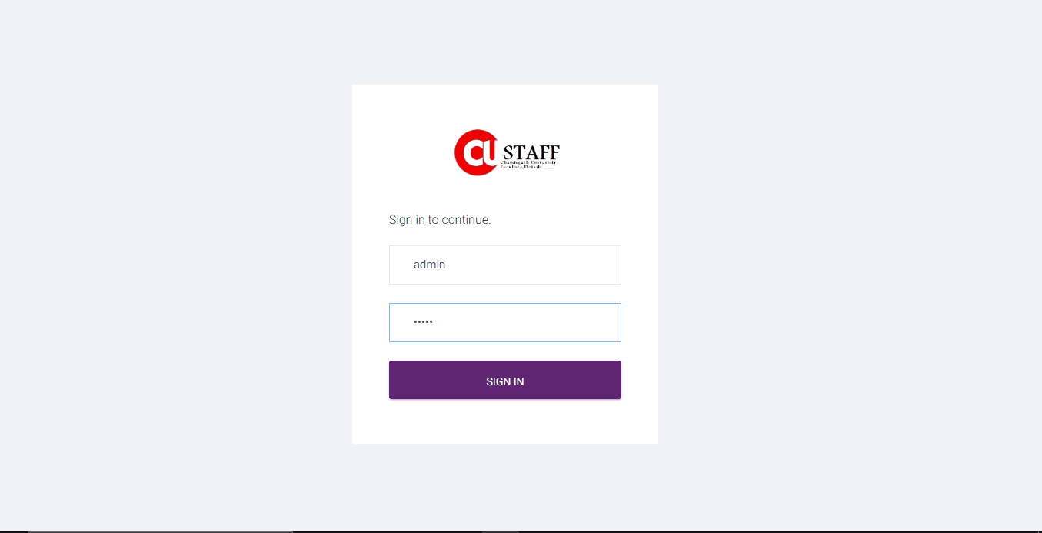

Figure 4.3.8[Admin Login Page]

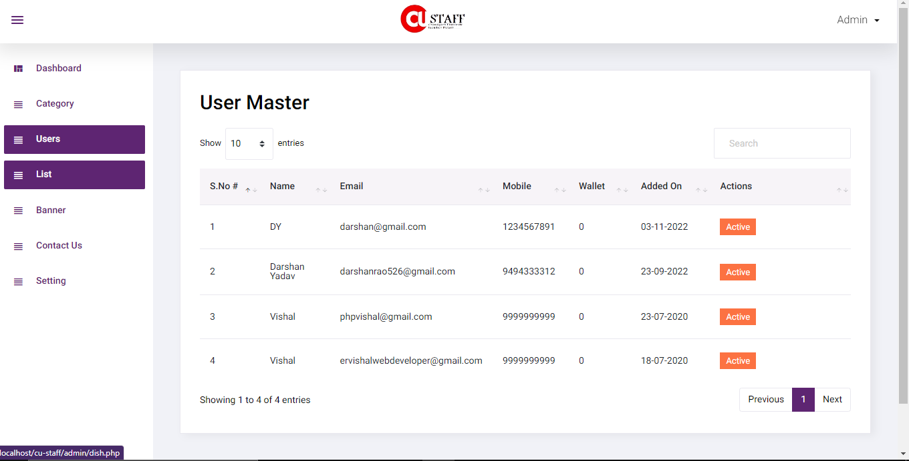

Figure 4.3.9[Admin Users Page]

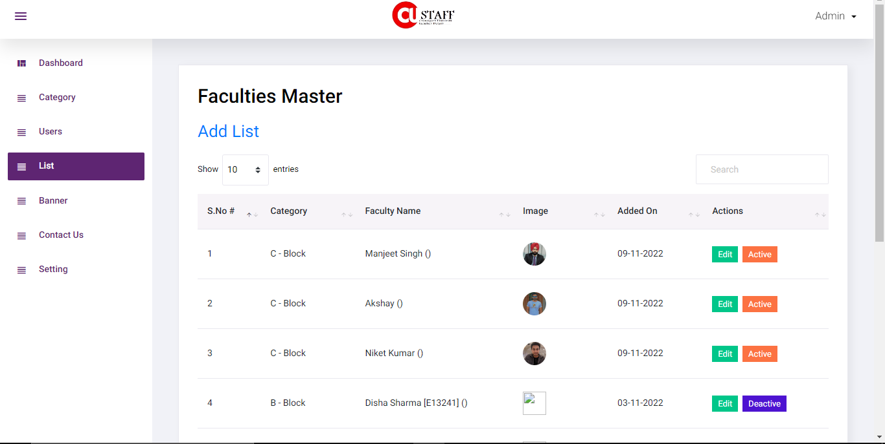

Figure 4.3.10[Admin List Page]

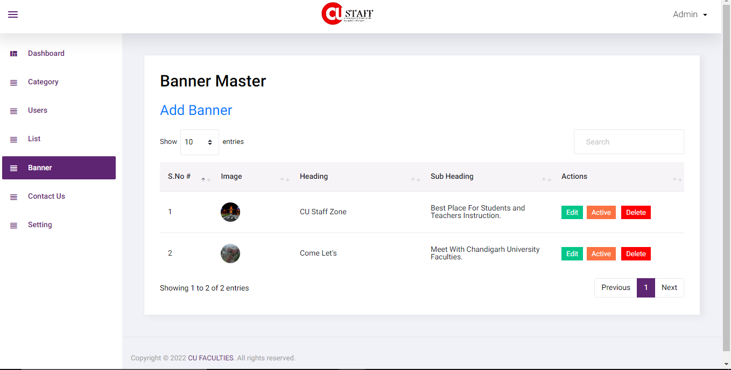

Figure 4.3.11[Admin Banner Page]

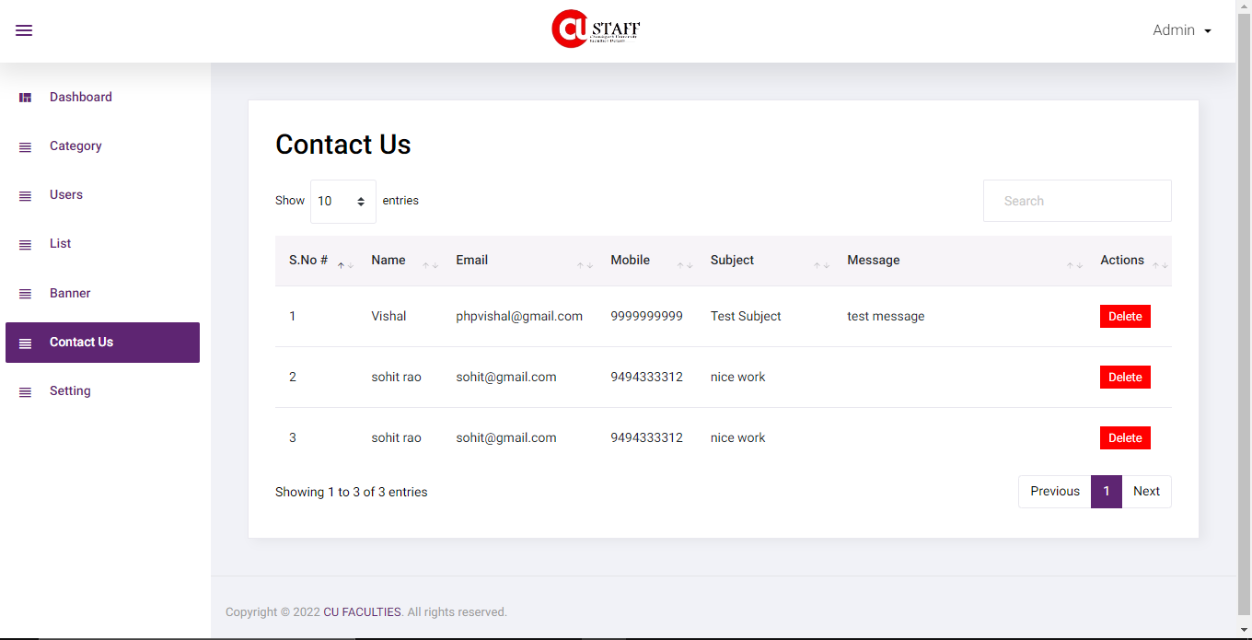

Figure 4.3.12[Admin Contact Page]

**4.4 Result Analysis:**

Despite having a lot of constraints and risks, till now we have achieved the feat of minimizing them and we hope to do so in the upcoming phases of the project. After analyzing all the aspects of our project i.e. features and possible constraints, we have decided on certain features and possible constraints, we have decided on certain features for our project that will be suitable.

Major among them are listed below:

**Live Chat:** A feature where your operators initiate the chat and reach out to your website visitors by offering instant help. This is a powerful tool for increasing customer satisfaction and engagement.

**Data Extend & format:** In feature updating the website our team make plane for adding new data, categories and voice searching for making the web smooth and attractive so that range of students/users is increase in the website.

**Analytics and Reporting:** Analytics gives you visibility into key areas of your operation and is arguably the most defining feature of this software. We can use analytics to know which problems to attack first. We can analyze this using Customer or user data, time spending and menu analytics and Inventory and procurement analytics.